How to use QLineEdit - An Example

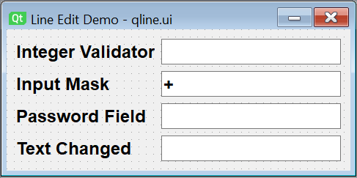

**Step 1**

**Adding the widgets to the form**

1. Drop four pairs of QLabel and QLineEdit widgets on the form and put them in Form Layout.
2. Change the names of the line edit fields to t1, t2, t3 and t4.

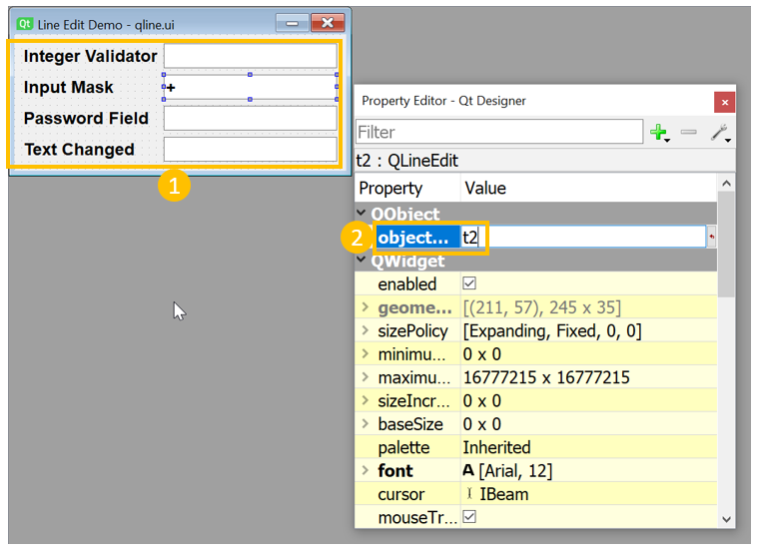

**Step 2**

**Setting properties and saving ui**

1. In order to let t2 to accept a phone number in the format +91 965 253 6547, set the InputMask property to +99 999 999 9999.

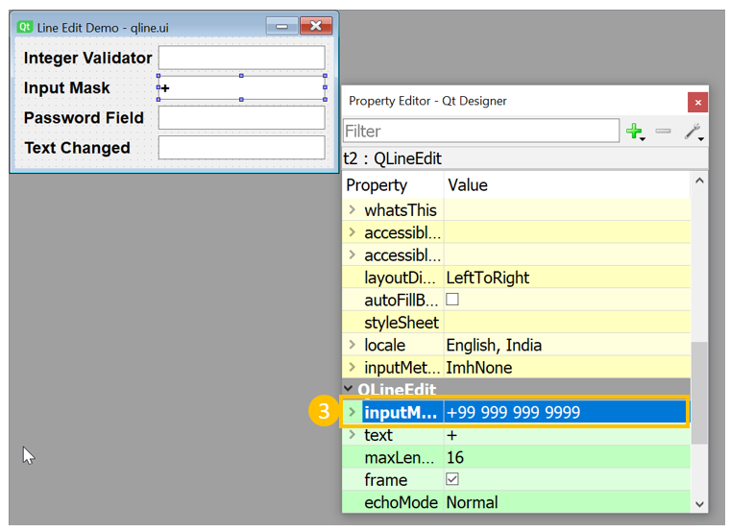

1. For t3, set EchoMode property to password.

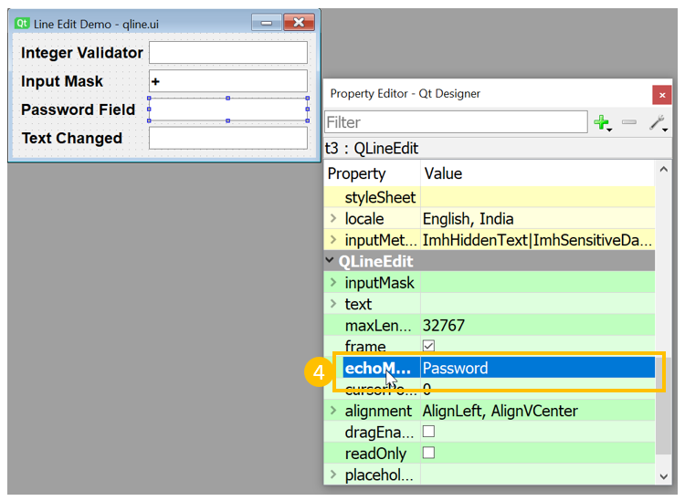

1. Save the form as qline.ui.
2. Using the pyuic5 utility, generate the Python script.

**Event Handling**

1. To restrict t1 to accepting integers, apply the IntValidator on t1 by add the following statement in setupUi() method.

**self.t1.setValidator(QtGui.QIntValidator())**

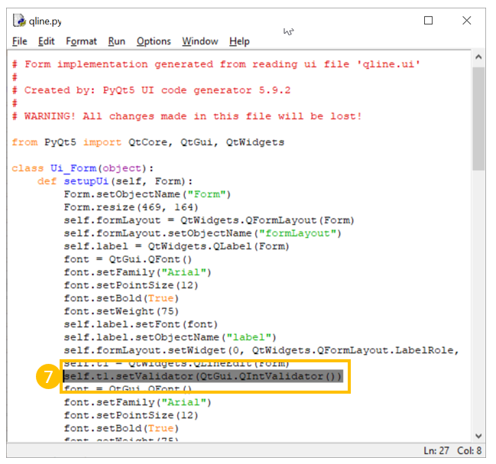

1. To restrict t4 to accept only alphabets, add the following method in the class Ui_Form.

**def textchange(self, text):**

**if text.isalpha()==False:**

**print ("non-alphabet character not allowed")**

**self.t4.setText("")**

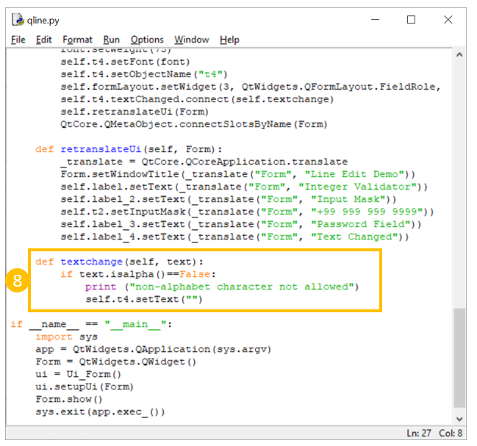

1. To set the method added above as a slot for textChanged signal emitted by t4, add the following statement in setupUi() method.

**self.t4.textChanged.connect(self.textchange)**

